THE GRANOT FAMILY KETUBAHS

The ketubah, or Jewish marriage contract, is a legal document believed to have originated more than 2000 years ago. Outlining a husband's obligations in marriage to his wife, the ketubah was created to confer legal and financial rights to her and marked a turning point in the rights of Jewish women.

The practice of illuminating manuscripts and of decorating ritual objects goes back many hundreds of years. Today, the ketubah is one of the predominant forms of Jewish art and is usually hung prominently in the home by the married couple as a daily reminder of their love, marriage vows and responsibilities to each other.

Archie Granot has created many ketubahs during his artistic career. Each is uniquely special but, understandably, the ketubahs he created for his marriage and for the marriages of his daughter and two sons - Galit, Ram and Roi - give him the greatest satisfaction.

____________________________

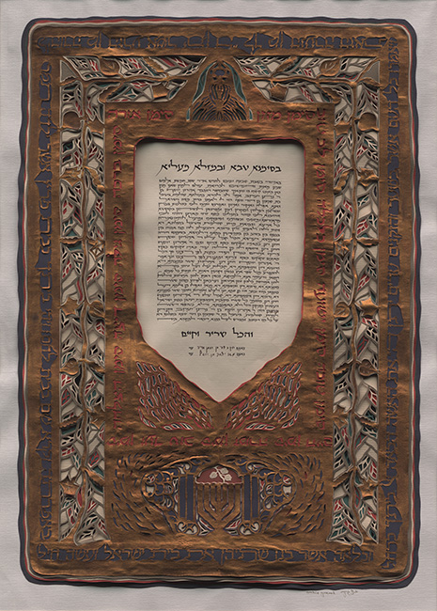
Ketubah of Susan and Archie Granot
Calligraphy: Izzy Pludwinski
Size: 69cm x 50cm
11 layers paper
Year: 1989

The Torah crown at the head of the ketubah symbolizes the rebirth of the Jewish people with the founding of the State of Israel. The pomegranates, above the menorah at the base of the papercut, derive from coins dating from the period of the Bar Cochba revolt against the Romans. Pomegranates are also a symbol of fertility and Hassidic wisdom informs us that every child is born in covenant between God and both parents. The single fruit facing two others reminds us of this. The vine that climbs around the ketubah is reference to the Biblical promise that the elderly will sit under the shade of the vine that they had planted in their youth. The Simanim (Sign of...) text around the inner border of the papercut is believed by some to originate from the (then) Jewish Community in Herat, Afganistan. It reads:

"With a good omen. A sign of light; A sign of blessing; A sign of rejoicing; A sign of delight; A sign of glory; A sign of fellowship; A sign of song; A sign of life; A sign of goodness; A sign of salvation; A sign of honour; A sign of companionship; A sign of food; A sign of comfort; A sign of forgiveness; A sign of help; A sign of fruitfulness; A sign of righteousness; A sign of uprightness; A sign of good health; A sign of peace; A sign of Torah; A sign of prayer." (The Hebrew appears in alphabetical order]

The text around the outer border of the papercut reads: "And all the people that were in the gate, and the elders, said, We are witnesses. May the Lord make the woman that is come into thy house like Rachel and like Leah, which two did build the house of Israel, and be prosperous in Efrata, and be famous in Bethlehem: And let thy house be like the house of Perez, whom Tamar bore unto Judah, of the seed that the Lord has given thee of this young woman." Ruth 4:11-12

____________________________

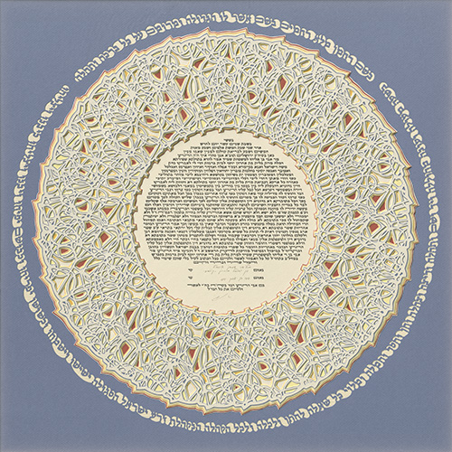

Ketubah of Galit and Avi Shalev
Size: 53cm diameter.
11 layers paper
Year: 1997

The round dancing shape of the ketubah decoration was created by skillful use of the the first letters of the name of bride and groom. The central text contains the marriage contract (ketubah) and the original calligraphy has been silkscreened.

The cutout text around the the papercut contains verses that were traditionally recited at the weddings of the Jews of Yemen and reads: "In the name of the Merciful, full of mercy. In the name of Him to whom greatness belongs, (whose name) is exalted above every blessing and praise. In a most auspicious time and a commended season, with strength, repute and glory, delight and exultation, grace, favor and compassion, fulfillment of every wish to the bridegroom and the bride and the entire assembled community, the chosen seed of Israel. May they rejoice and be joyful, blossom and spread like fragrance. May they build and prosper, build and prosper."
____________________________

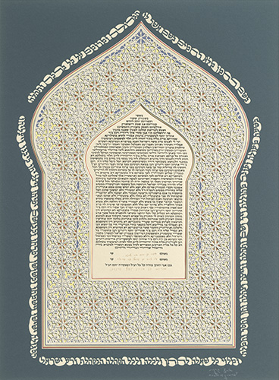

Ketubah of Galia and Ram Granot
Size: 60cm x 41.6cm
11 layers paper
Year: 1997

The cutout text around the papercut, itself inspired by Middle East ornamentation, contains a text, traditionally recited at the weddings of the Jews of Yemen, that reads:

"In the name of the Merciful, full of mercy. In the name of Him to whom greatness belongs, (whose name) is exalted above every blessing and praise. In a most auspicious time and a commended season, with strength, repute and glory, delight and exultation, grace, favour and compassion, fulfillment of every wish to the bridegroom and the bride and the entire assembled community, the chosen seed of Israel. May they rejoice and be joyful, blossom and spread like fragrance. May they build and prosper, build and prosper.”

____________________________

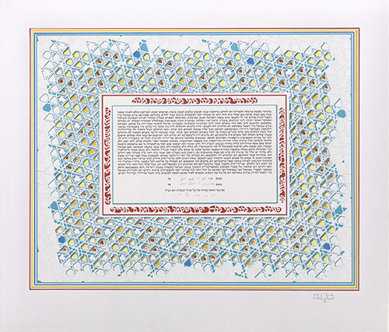

Ketubah of Avital and Roi Granot
Size: 52cm x 44cm
12 layers paper
Year: 2000

The Ketubah text is bordered by excerpts from the Friday night Sabbath service Lecha Dodi prayer (composed by Rabbi Shlomo Alkabets, the 16th century kabbalist, who lived in Safed). "Lecha Dodi Likrat Kallah" - "Come my beloved to greet the Bride, let us welcome the Shabbat presence."

This prayer, recited on the Sabbath eve, allegorically shows the people of Israel greeting the approaching Sabbath as, at the wedding ceremony, the groom awaits his bride. It was especially appropriate that the bride and groom to chose this text to adorn their ketubah.

The design for the papercut was inspired by the Magen David - Star of David - while the primary colors of the work - blue and white - are those of the State of Israel. The top white layer has a border that has been cut out to create the appearance of an etching.

